The virtual trade show for metrology and quality assurance from HEIDENHAIN:
High-end encoder accuracy that reaches the application

In May, HEIDENHAIN and its brands AMO, ETEL, NUMERIK JENA, and RSF will be hosting their virtual trade show for metrology and quality assurance. On a microsite and through live presentations in online meetings, the Sales and Product Management teams will present new encoders and other motor and drive technologies that bring greater efficiency to metrology solutions. To view the innovations and information for scheduling a personal presentation, customers can visit metrology.heidenhain.com.

Transferable accuracy: the MRP angle encoder modules from HEIDENHAIN ensure that full encoder accuracy is realized in the application
The MRP 8000 angle encoder modules from HEIDENHAIN merge high-resolution measurement technology with a stable bearing. They are an attractive solution for manufacturers of measuring machines, laser trackers, wafer handling machines, EDM machines, and micro-precision manufacturing machines. As completed assemblies with defined specifications, they facilitate the design of high-accuracy rotary axes.

To ensure that the module’s accuracy reaches the application, HEIDENHAIN has already matched, assembled, and adjusted all of its components, thus alleviating the customer of all critical assembly processes. The new MRP 8081 variant even features a second scanning head for considerably greater robustness. As a result, the specified system accuracy can still be achieved in the face of high tilting loads, vibrations, or thermal fluctuations.

Advanced metrology: the MRS angle encoder module from HEIDENHAIN and the modular angle encoders from RSF for high-accuracy measuring arms and measuring robots
HEIDENHAIN will be presenting the new MRS angle encoder modules for applications requiring highly compact and rigid bearings. They are optimized for low to medium speeds and medium loads. Specially designed for advanced metrology applications such as measuring arms or measuring robots, they feature superb tilting rigidity, a high maximum permissible tilting load, and exceptional repeatability.

RSF will be presenting a highly versatile solution for advanced metrology. Thanks to its modular design, the new closed MBR scale tape ring for the MCR 15 and MSR 15 modular angle encoders can be used in a variety of ways as well as adapted to the application. Customers benefit from a highly accurate encoder that is optimally matched to the metrology solution.

High-accuracy rotary axes: the ERO 2000 and ERP 1000 modular angle encoders from HEIDENHAIN with consistently high signal quality
The ERO 2000 modular angle encoders from HEIDENHAIN are ideal for highly dynamic applications with high accelerations. This is due to their low mass and low mass moment of inertia. For larger axes, the ERP 1000 modular angle encoders from HEIDENHAIN are available as an alternative. For both solutions, the HSP 1.0 ASIC developed by HEIDENHAIN ensures consistently high scanning signal quality. The ERO 2000 and ERP 1000 are very easy to install thanks to their wide mounting tolerances, within which the quality of the output signals is negligibly affected.

Dynamic linear axes: the new LIC 3000 linear encoders from HEIDENHAIN with small measuring steps and high travel speeds
The LIC 4000 and LIC 2000 product range of exposed, absolute linear encoders now includes the new LIC 3000 series, combining very small measuring steps of only 10 nm with high traversing speeds of up to 600 m/min. The LIC 3000 linear encoders thereby enable highly dynamic and highly accurate position measurement on linear axes with measuring lengths of up to 10 nm. Their large scanning field makes the LIC 3000 series particularly immune to contamination. Localized impurities on the measuring standard have minimal effect on the signal quality and measurement reliability. Thanks to their dynamic performance, long measuring lengths, and robustness, the exposed linear encoders of the LIC 3000 series are particularly versatile, bringing the advantages of LIC encoders to even more applications.

In addition to these highlights and innovations, there are more exciting solutions for visitors to discover at the virtual trade show for metrology and quality assurance:
- The KCI 120 Dplus dual encoder from HEIDENHAIN offers motor feedback and position measurement in just one rotary encoder that compensates for inaccuracies inherent to highly mobile and dynamic joints.
- The LIKgo and LIKselect ultra-small linear encoders from NUMERIK JENA are ideal for installation in confined spaces. They also meet high accuracy requirements.
- The ILF+ ironless linear motors from ETEL, in combination with the IWM+ magnetic track, are ideal for demanding inspection scan applications requiring stability at high speed and zero magnetism.

Demo units and practical examples of applications will also be featured:
- A setup featuring ACANTO length gauges and the GAGE-CHEK 2000 evaluation unit will show how a measuring station can become a versatile and digitally networked workstation.
- HEIDENHAIN will be demonstrating bus operation with the EnDat 3 interface using three different encoders with position feedback, sensor information, and monitoring data transmitted by EnDat 3 over only four wires at a cycle time of 30 µs. The benefits are reduced cabling, the functional safety capability, and extensive diagnostics. This makes EnDat 3 the ideal encoder interface for achieving high system integration and meeting the requirements of future digitalization, along with system cost savings and a versatile machine architecture.
- The SRP 5000 angle encoder modules combine a HEIDENHAIN MRP angle encoder module with an ETEL torque motor. They enable particularly smooth motion control: neither disruptive cogging torques nor radial forces influence the high guideway accuracy of the bearing. This will be shown with a demonstration unit that compares the system accuracy and radial guideway accuracy of a conventionally built bearing with that of the SRP 5000.

The virtual trade show for metrology and quality assurance from HEIDENHAIN and its brands AMO, ETEL, NUMERIK JENA, and RSF.

Starting on May 3, 2021, online at: metrology.heidenhain.com

Contact persons for the trade press:
presse@heidenhain.de

Frank Muthmann
Tel.: +49 8669 31-2188

Ulrich Poestgens
Tel.: +49 8669 31-4154

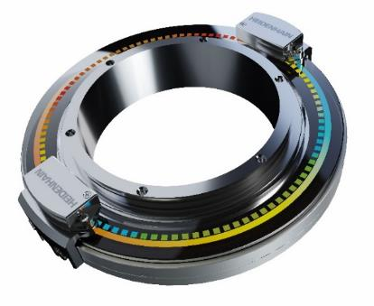 | Transfer specified accuracy to the application: transferable accuracy exemplified by the MRP 8081 angle encoder module with two scanning heads from HEIDENHAIN.
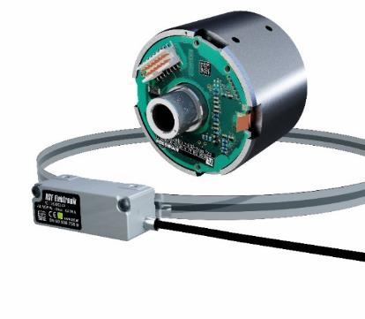 | Higher accuracy for measuring arms and metrology robots in advanced metrology: the MRS angle encoder module from HEIDENHAIN and the modular angle encoders from RSF with the new MBR scale tape ring.
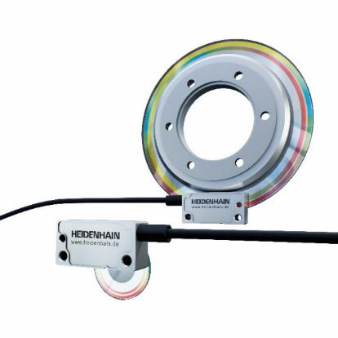 | High resolution and accuracy in measuring setups: the ERO 2000 and ERP 1000 modular angle encoders from HEIDENHAIN.
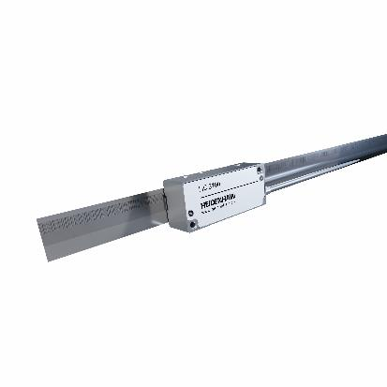 | For larger measuring lengths and high traversing speed: the new LIC 3000 from HEIDENHAIN rounds out the renowned LIC series.

